Water in Fuel Telltale - CGEA1.3

Functional Description

The purpose of the Water_In_Fuel_Telltale is to inform the driver that there is water in the fuel system.

The Water_In_Fuel_Telltale WATER_IN_FUEL Signal from the ECM and the Operational_Mode illuminate or extinguish the Water_In_Fuel_Telltale.

The Water_In_Fuel_Telltale shall provide an iconic representation that will illuminate or extinguish to inform the driver that there is water in the fuel system.

Interfaces

Interface Context Diagram (I/O Block Diagram)

Figure 1 Water in Fuel Telltale Context Diagram
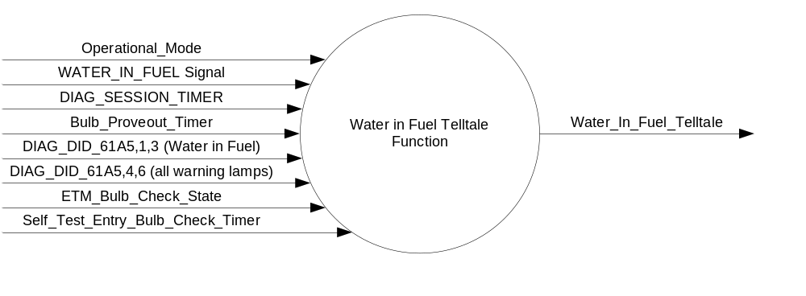

Inputs
      - INTERNAL:
            - DIAG_SESSION_TIMER
            - Operational_Mode
            - Bulb_Proveout_Timer
            - DIAG_DID_61A5,1,3 (Water in Fuel)
            - DIAG_DID_61A5,4,6 (all warning lamps)
            - ETM_Bulb_Check_State
            - Self_Test_Entry_Bulb_Check_Timer

MUX message on the CAN Bus from the ECM.

- WATER_IN_FUEL Signal
Signal Name | Size (bits) | Detail | Units | Res. | Offset | State Encoded | Min | Max
WATER_IN_FUEL | 1 |  | SED | 1 | 0 |  | 0 (0x0) | 1 (0x1)
 |  | No |  |  |  | 0x0
 |  | Yes |  |  |  | 0x1

Outputs
Water_In_Fuel_Telltale, which is used to control the state of the LED

Function/Performance

Operational Modes

Mode | Differentiating Vehicle Conditions
Sleep Mode | Water in Fuel TT OFF
Limited Mode | Water in Fuel TT OFF
Normal Mode | Water in Fuel TT OFF/ON
Crank Mode | Water in Fuel TT OFF/ON

Voltage Levels

Refer to the Cluster Features table located in the Operational Modes and Voltage Range Stategies Section in this SPSS

Human-Machine Interface

Visual

Indicator Graphics / Display Format


For actual symbol definition refer to database # G.10 of the 03-0685 ARL requirement

Indicator Color Coordinates

Amber - Reference SDS IL-0017/IS-0379

Indicator Characteristics

LED – Water in Fuel Telltale

Audio

None

Switch Control Logic

Not Applicable

System Accuracy

The Water_In_Fuel_Telltale shall change the state of the Telltale within 100msec of a state change as indicated in the state matrix reference 1.3.5.1 Subsystem Algorithm Flowchart/ State Diagram

Operation: Performance and Functional

Subsystem Algorithm Flowchart / State Diagram

Table 1.1 State Matrix for Water_In_Fuel_Telltale
Operational_Mode | ETM_Bulb_ Check_State | DIAG_SESSION_TIMER | Self_Test_Entry_Bulb_Check_Timer | DIAG_DID_61A5,1,3 (Water in Fuel) | DIAG_DID_61A5,4,6 (all warning lamps) | Bulb_Proveout_Timer | WATER_IN_FUEL Signal | Water_In_Fuel_Telltale
Normal or Crank | X | Inactive | X | X | X | Active | X | ON
Normal or Crank | X | Inactive | X | X | X | X | YES (0x1) | ON
Normal or Crank | ON (0X1) | Inactive | X | X | X | X | X | ON
Normal | X | Active | Inactive | Not Received | Not Received | Active | X | ON
Normal | X | Active | Inactive | Not Received | Not Received | X | YES (0x1) | ON
Normal | ON (0X1) | Active | Inactive | Not Received | Not Received | X | X | ON
Normal | X | Active | X | ON (0x1) | X | X | X | ON
Normal | X | Active | X | X | ON (0x1) | X | X | ON
Normal | X | Active | Active | X | X | X | X | ON
Normal | OFF (0x0) | X | Inactive | Not Received | Not Received | Inactive | Missing as per 1.4.1 | OFF
All Other Cases |  |  |  |  |  |  |  | OFF
X = Don’t Care
Not Received = The state when a DIAG_SESSION_TIMER is active and the DID has not been received

Operation Description (supports algorithm flowchart /state diagram)

Function Safety Classification (EMC)

Class B

Memory Storage

Parameter Name | Description | Value at  Battery Connect | Value at  Module Wake-up
Water_In_Fuel_Telltale | Used to control the state of the LED | OFF (0x0) | OFF (0x0)
WATER_IN_FUEL Signal | CAN signal sent from the ECM | No (0x0) | Do Not Init
DIAG_DID_61A5,1,3 (Water in Fuel) | Warning Lamp status 2, byte 1, bit 3 (Water in Fuel) | 0 (0x0) | 0 (0x0)
DIAG_DID_61A5,4,6 (all warning lamps) | Warning Lamp status 2, byte 4, bit 6 (all warning lamps) | 0 (0x0) | 0 (0x0)
ETM_Bulb_Check_State | State indicator for warning bulb in ETM | OFF (0x0) | OFF (0x0)
Operational_Mode | 4 state indicator for cluster operational mode | Limited | Limited, Normal or Crank

Parameter Name | Description | Value at  Battery Connect | Value at  Module Wake-up
DIAG_SESSION_TIMER | Timer used to time-out a diagnostic session | Inactive | Inactive
Self_Entry_Bulb_Check_Timer | Timer used in diagnostic session to do a self check of telltales | Inactive | Inactive
Bulb_Proveout_Timer | Timer used in diagnostic session to do a self check of telltales | Inactive | Inactive

Prove Out

3.0 +/- 0.1 seconds as per bulb prove out section. Cluster controls prove out. No DTC's shall be logged while in prove out.

Reconfigurable Telltale

No

Message Center Msg

See Message Center Function

Error Handling

Missing Message Strategy

The signals will be declared missing as per the Diagnostics section of this SPSS.

DTCs states and history will be determined as per the Diagnostics section of this SPSS.

If the cluster is not configured to be a Diesel variant, the cluster shall never log a missing message DTC due to this feature.

Diagnostics

Self Test

Bulb illuminated during self test as per Self_Entry_Bulb_Check_Timer

Engineering Test Mode

Reference section “Dealer / Engineering Test Mode (ETM)”

Part II Performance

Supported Diagnostic DIDs (Service $22 and $2F)
Number | DID / CommonID Name | DID Type
61A5 | Warning Lamp Status 2, byte 1, bit 3 (Water in Fuel) | Bit Mapped
61A5 | Warning Lamp Status 2, byte 4, bit 6 (all warning lamps) | Bit Mapped

Supported Diagnostic Trouble Codes (DTCs)

DTCs shall be logged as per the diagnostic section of this SPSS.

DTC | Description
C10000 | Lost communication with ECM/PCM

Reference Specification

FU-1125 DIESEL FUEL WATER SEPARATOR REQUIREMENTS

IS-0001 WARNINGS/INDICATORS/DISPLAYS PROVEOUT
IS-0046 INSTRUMENTATION MATERIAL RESISTANCE TO CLEANING
IS-0052 OPERATING VOLTAGES - FUNCTIONAL/PERFORMANCE
IS-0069 FUNCTIONAL IMPORTANCE CLASS
IS-0324 WINDSHIELD & OTHER REFLECTIONS
IS-0327 WARNING INDICATOR EVALUATION
IS-0329 FLICKERING OF LAMPS
IS-0379 NORTH AMERICAN WARNINGS AND INDICATORS STRATEGY

IL-0017 TELLTALE AND INTERIOR ILLUMINATION COLOR
IL-0021 CRAFTSMANSHIP - DISPLAYS
IL-0023 CLARITY/LEGIBILITY/READABILITY
IL-0025 INTERIOR ILLUMINATION INTENSITY
IL -0027 VISUAL CONTRAST
IL -0043 OPERATIONAL ENVIRONMENT FUNCTIONALITY
IL -0045 COLOR
IL -0047 TELLTALE; INDICATOR AND DISPLAY LIGHT INTENSITY
IL -0048 ILLUMINATION ACCEPTABILITY

03-0661 PLACEMENT: CONTROL AND DISPLAY LOCATIONS
03-0662 PLACEMENT: LOGICAL GROUPING FUNCTION AND USAGE
03-0664 PLACEMENT: DOWN VISION TO COMPONENTS WITH HIGH VISUAL DEMAND
03-0665 PLACEMENT: EXPECTED LOCATIONS OF CONTROLS AND DISPLAYS VDS
03-0670 INTERIOR VISIBILITY
03-0671 INTERIOR VISIBILITY: REFLECTIONS FROM COMPONENTS & SURFACES
03-0672 INTERIOR VISIBILITY: REFLECTIONS IN DISPLAYS
03-0673 INTERIOR VISIBILITY: VISUAL OBSCURATIONS
03-0674 INTERIOR VISIBILITY: ILLUMINATION CONTROLS / DISPLAYS
03-0675 INTERIOR VISIBILITY: VEILING GLARE
03-0677 INTERIOR VISIBILITY: SUNLIGHT WASHOUT
03-0681 IDENTIFICATION: CHARACTER AND SYMBOL SIZE
03-0682 IDENTIFICATION: LEGIBILITY
03-0685 IDENTIFICATION: SYMBOLS, ABBREV FOR CONTROL
03-0721 LOGIC OF OPERATION: OPERATIONAL STEREOTYPES
03-0722 LOGIC OF OPERATION: INTERPRETATION
03-0723 LOGIC OF OPERATION: USE OF SYSTEMS WITH VISUAL DISPLAYS

Revision History
SPSS Module Revision History

Revision Level | Name | Change Description | Date
1.0 | V.Patel | Updated for CGEA 1.3 based on CGEA STSS v1.0  Section 1.2.2 – Deleted table referencing the HS-CAN message that contains the input signal. Deleted “ID” and “Pos” columns from table 1.0  Section 1.3.5.1 – Added a row to specify missing message action in table 1.1  Section 1.4 – Rewritten. Deleted references of specific missing message flags and timer.  Section 1.5.3 – Deleted DTC logging criteria from table. | 3/29/2010
1.1 | Jblatchf | 1.3.3.2.1: Changed color from Red to Amber to reflect as manufactured. | 2/28/2013

